**Q)** Write a Python program to prepare Scatter Plot for Iris Dataset.

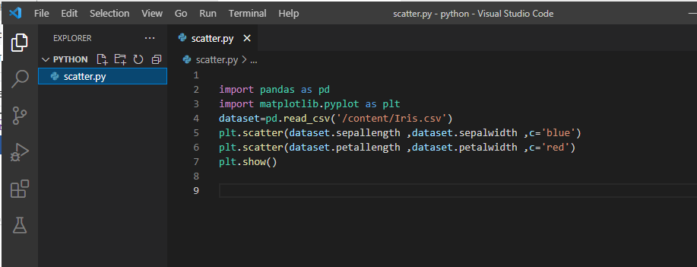

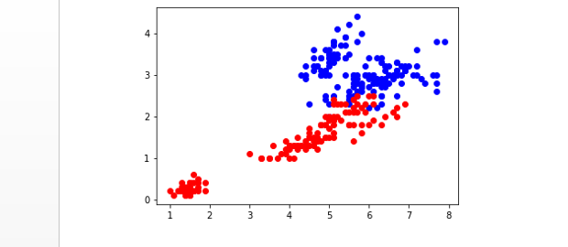

Write a python program to find all null values in a given dataset and remove them.

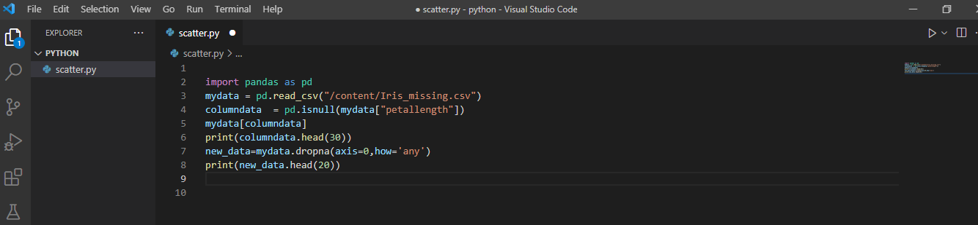

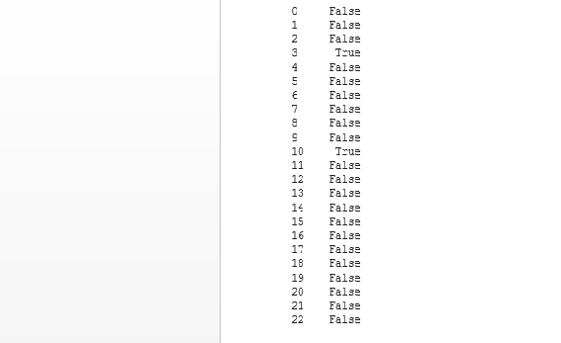

Write a python program to make Categorical values in numeric format for a given dataset.

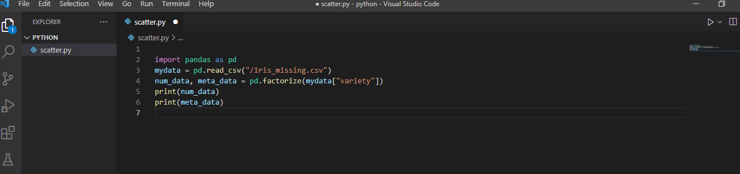

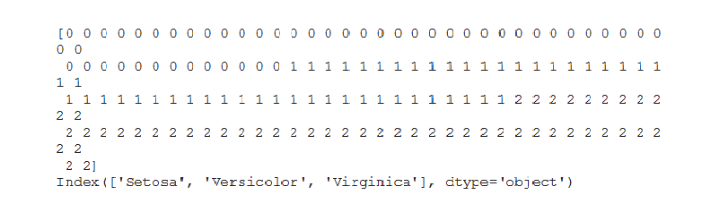

Write a python program to Implement Simple Linear Regression for predicting house price.

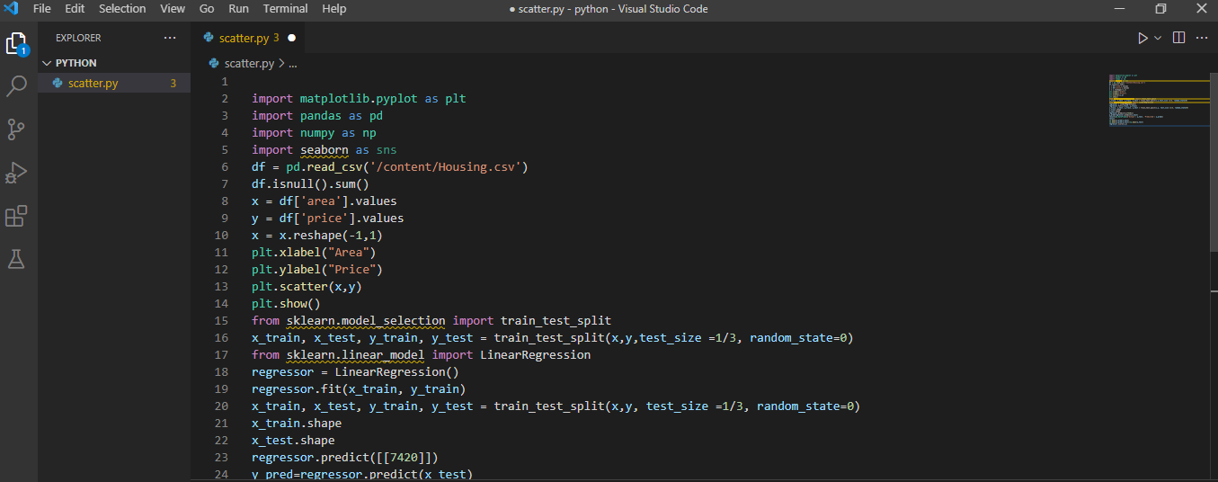

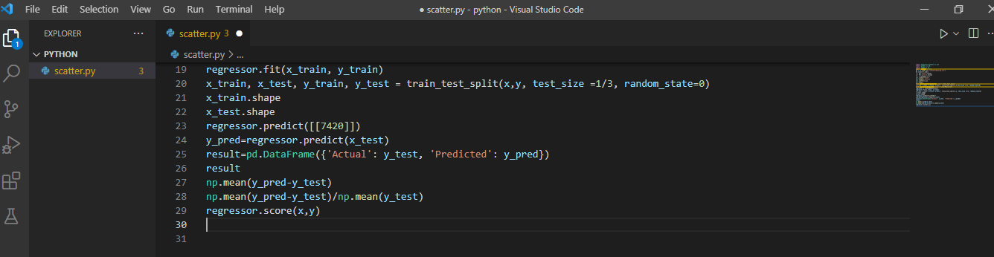

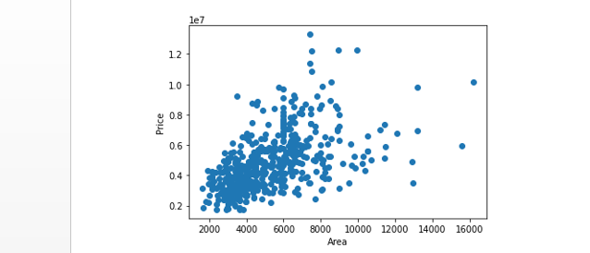

Write a python program to implement Multiple Linear Regression for a given dataset.

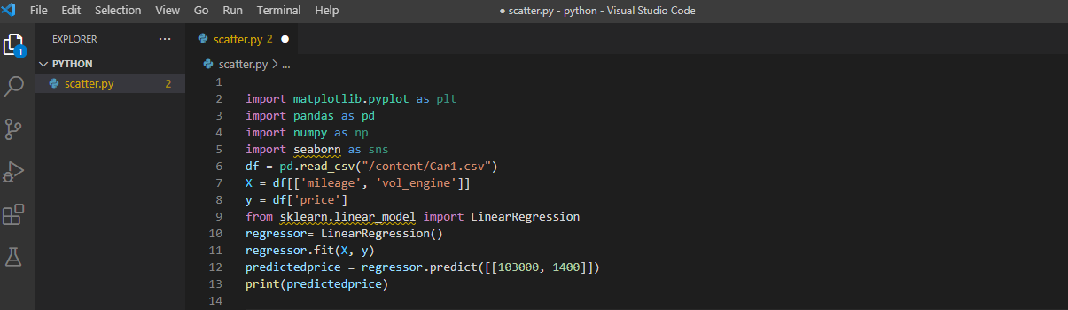

Don’t have output

Write a python program to implement Polynomial Regression for a given dataset.

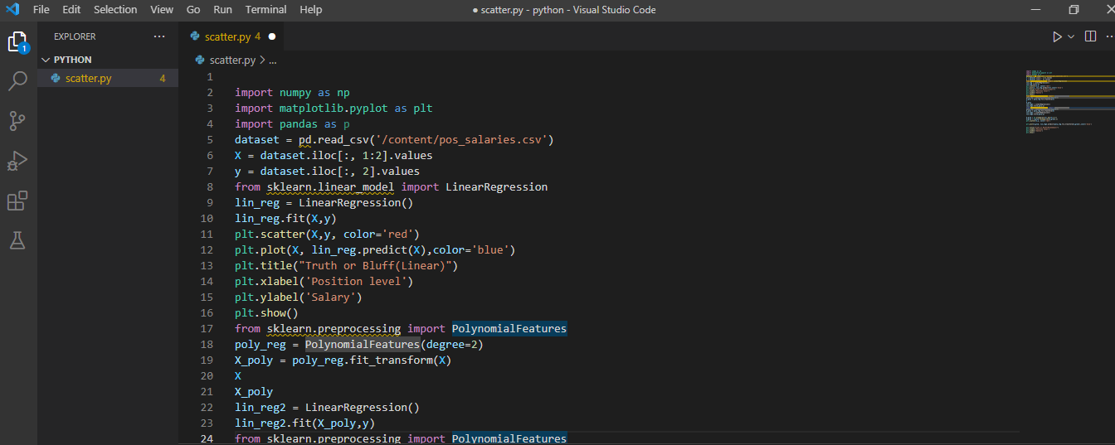

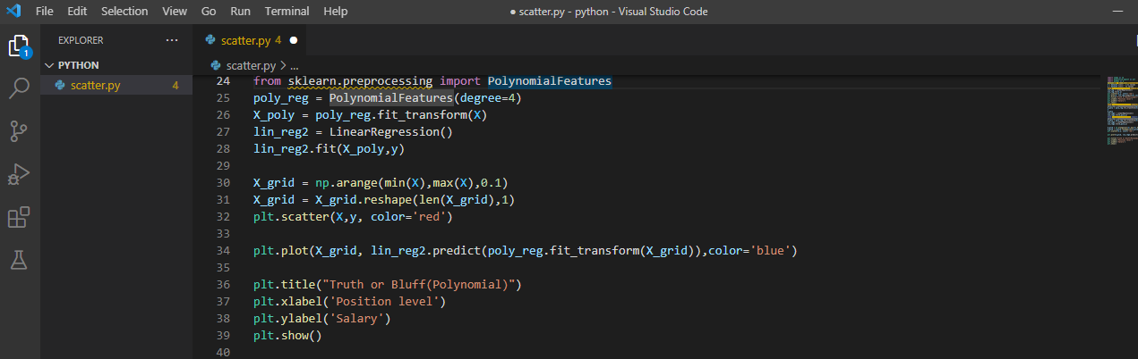

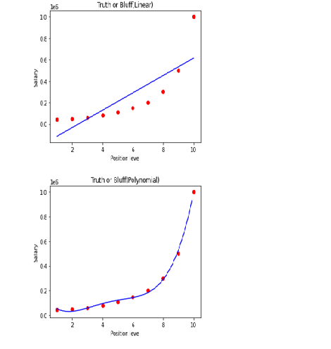

Write a python program to Implement Naïve Bayes

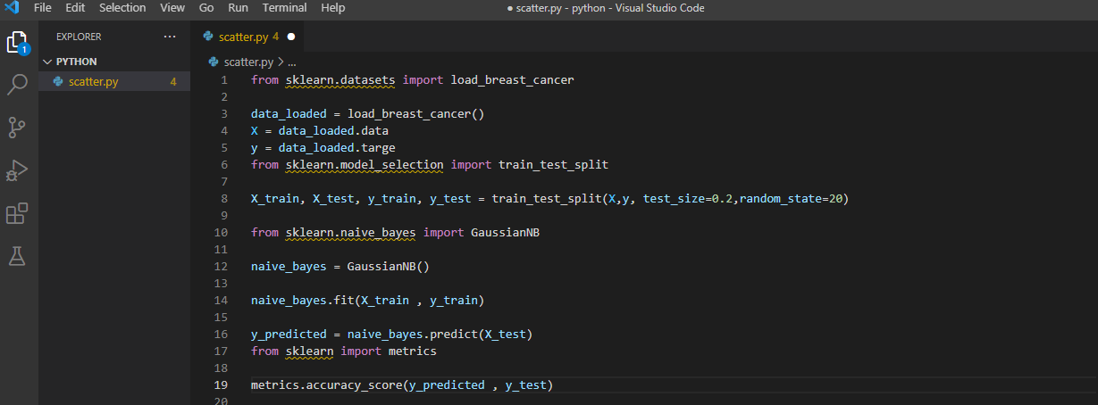

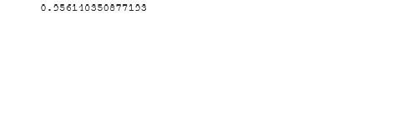

Write a python program to implement Decision Tree whether or not to play Tennis.

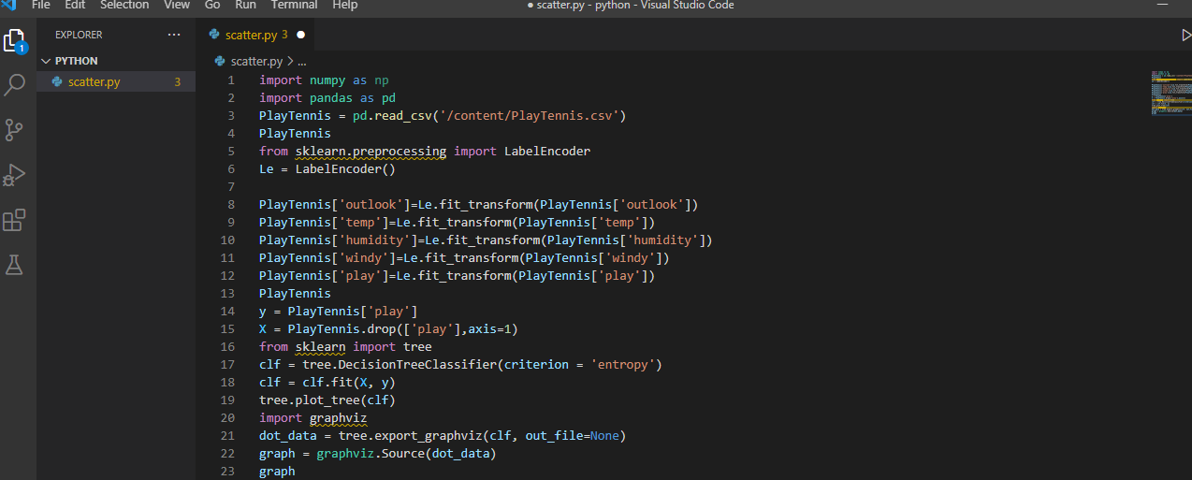

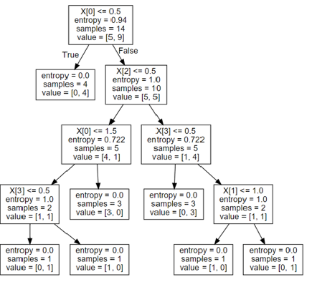

Write a python program to implement Linear SVM.

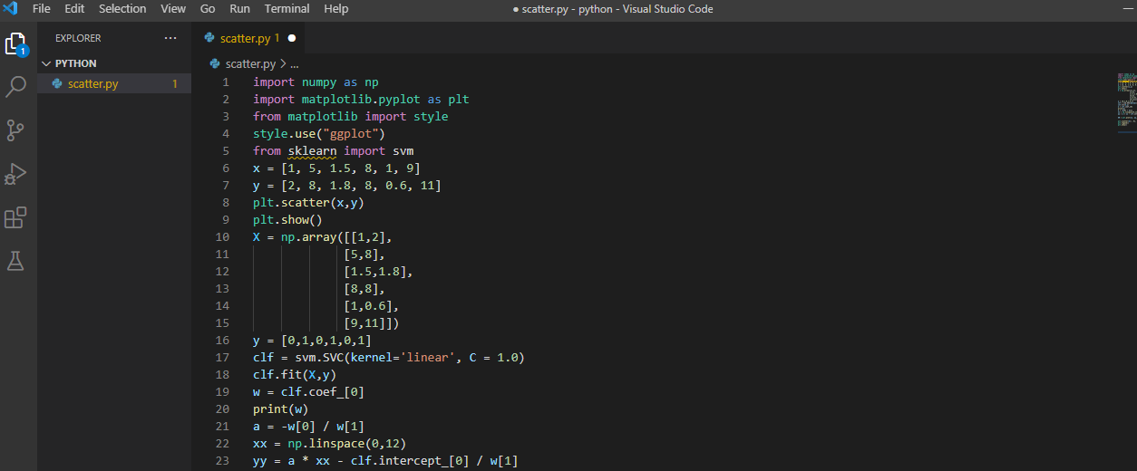

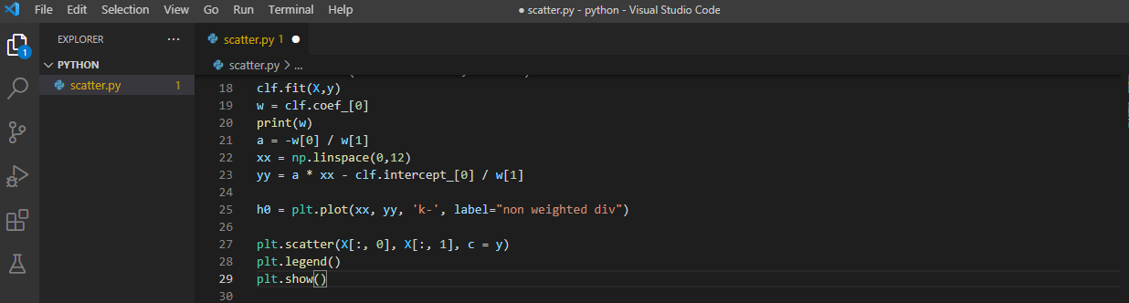

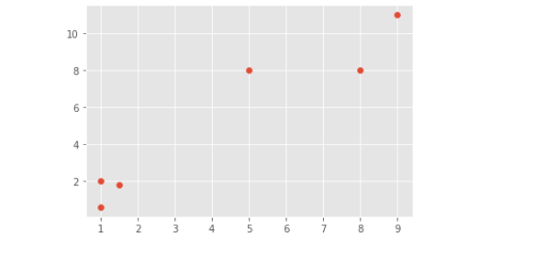

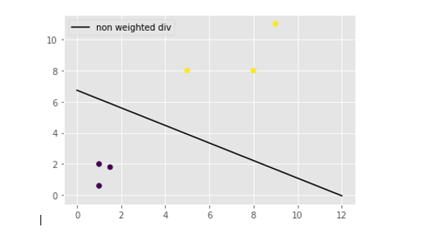

WEBFREAME WORK:

Create an HTML form that contain the Student Registration details and write a JavaScript to validate Student first name and last name as it should not contain other than alphabets and age should be between 18 to 50.

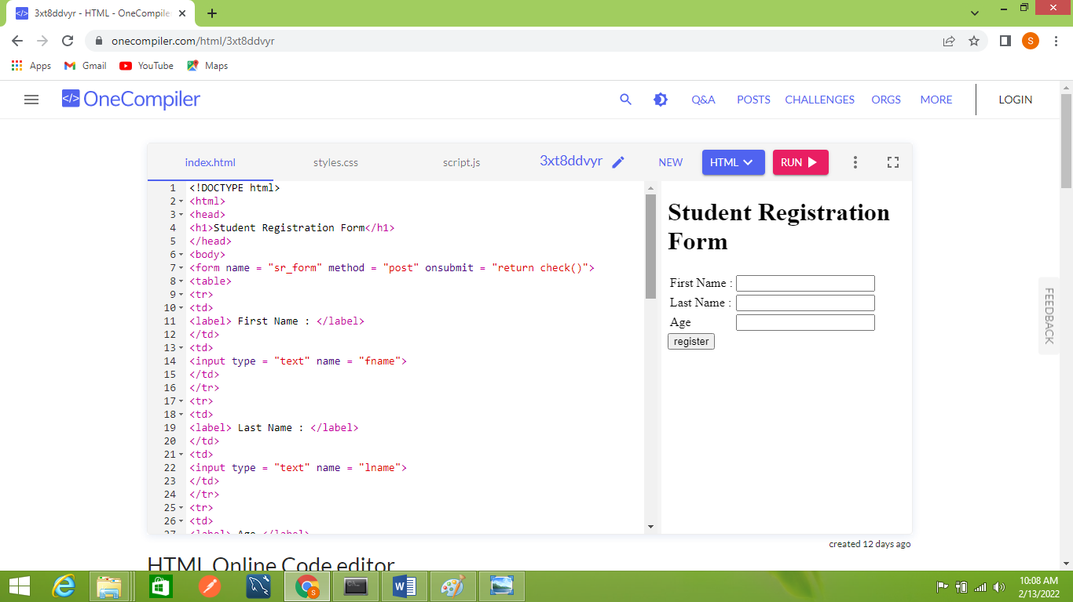

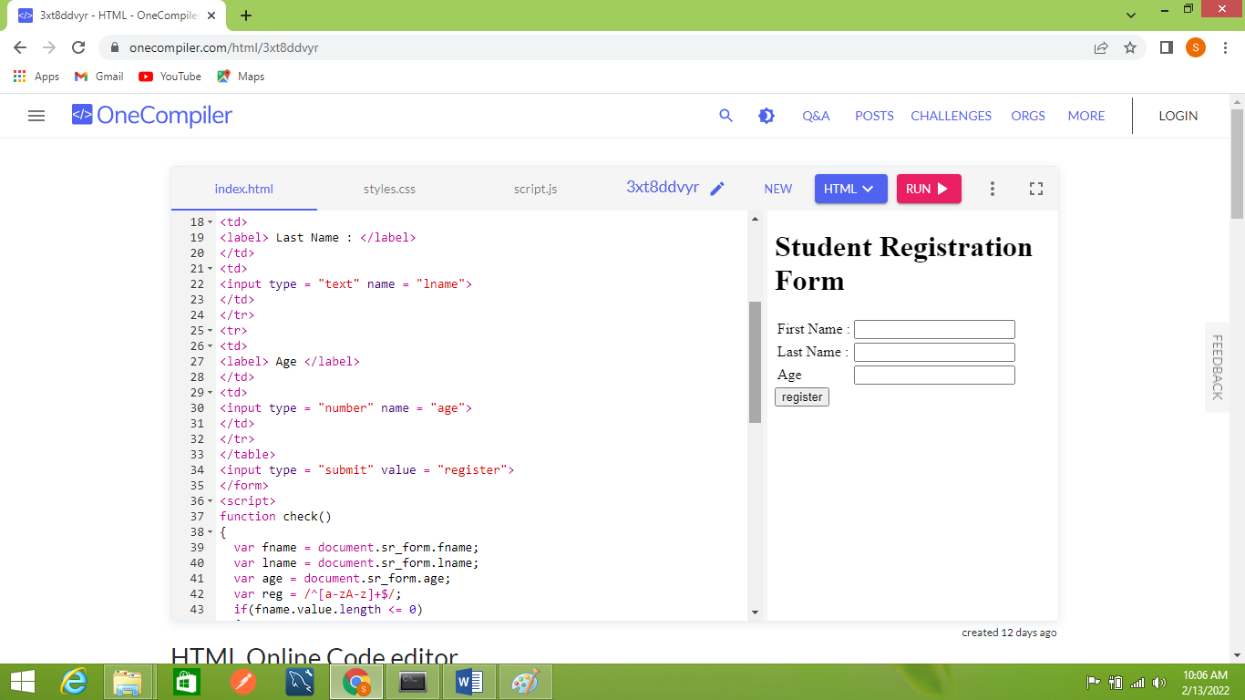

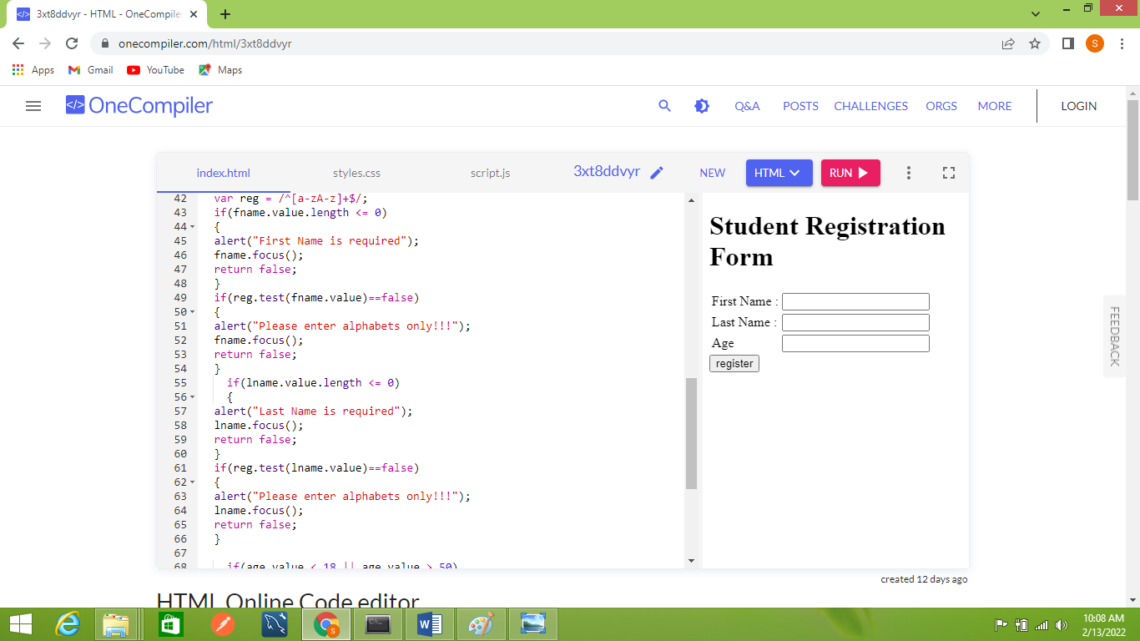

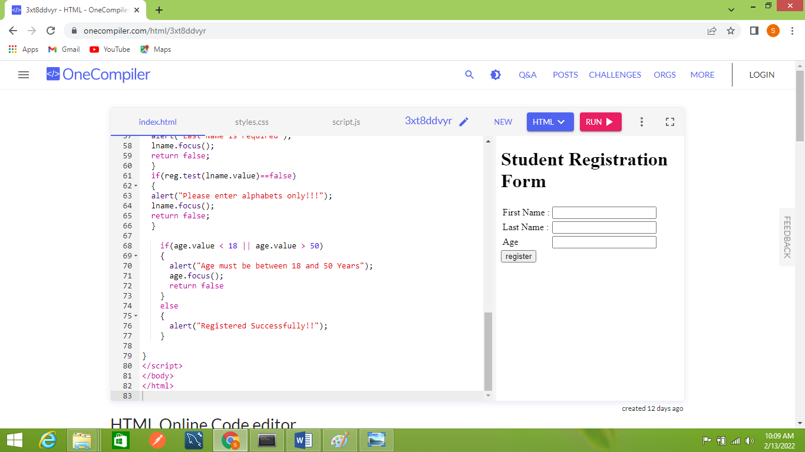

Create a HTML form that contain the Employee Registration details and write a JavaScript to validate DOB, Joining Date and Salary.

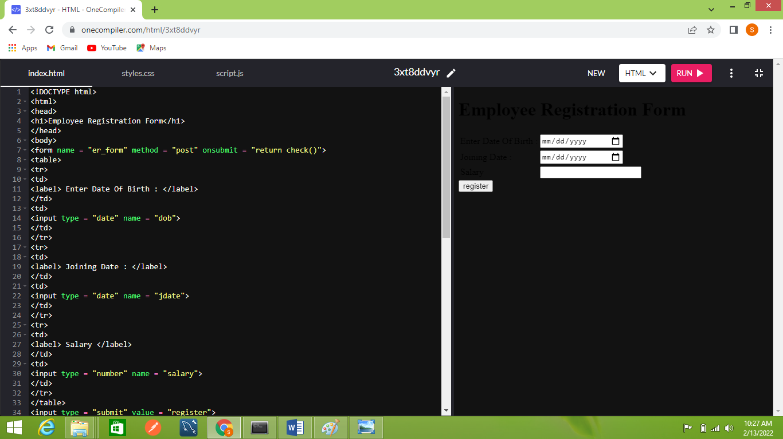

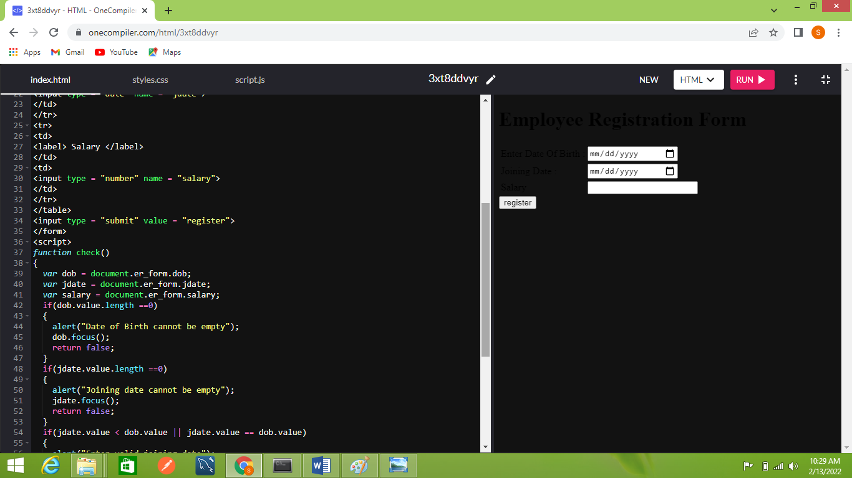

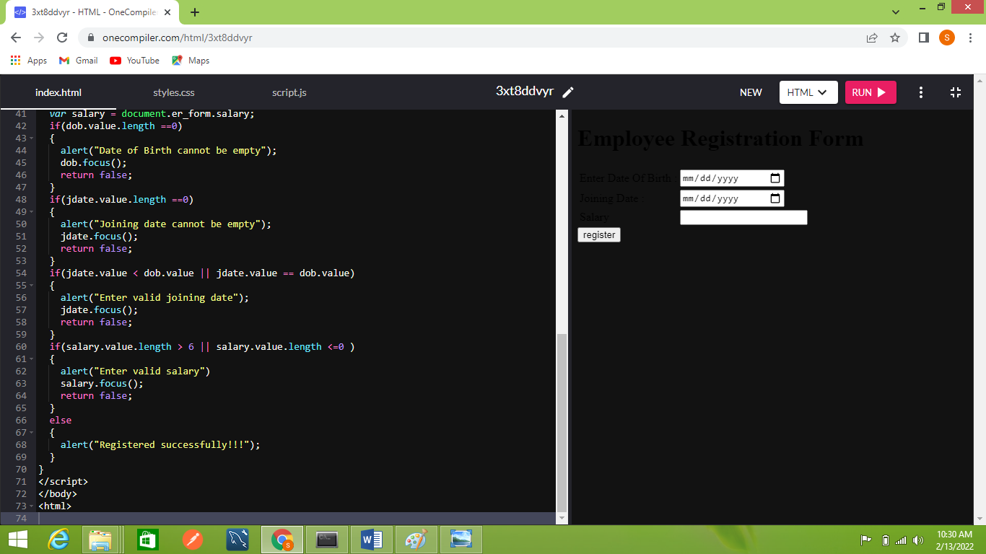

Create a HTML form for Login and write JavaScript to validate Email ID using Regular Expression

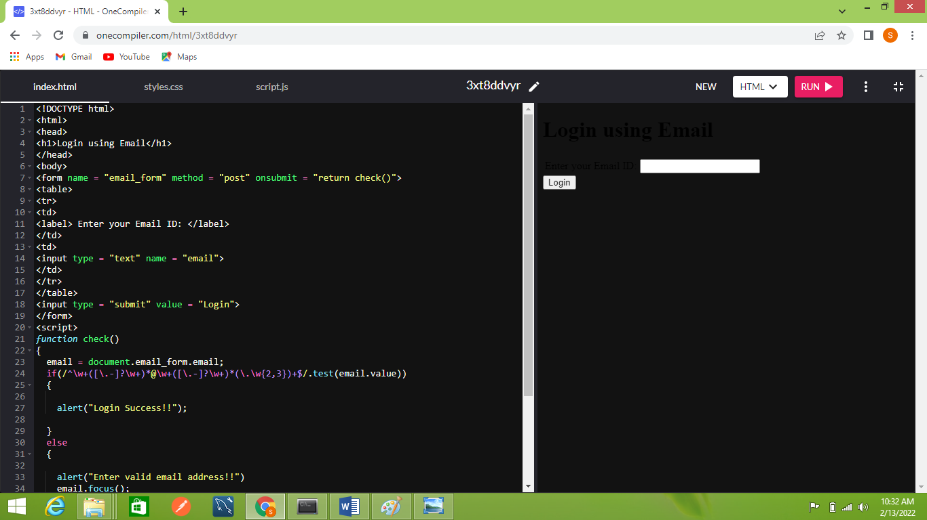

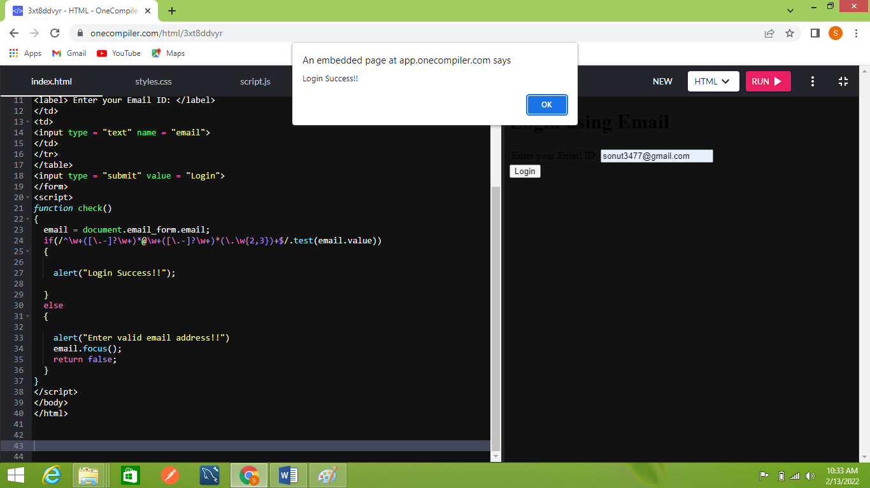

Create a Node.js file that will convert the Output “Hello World!” into upper- case letters.

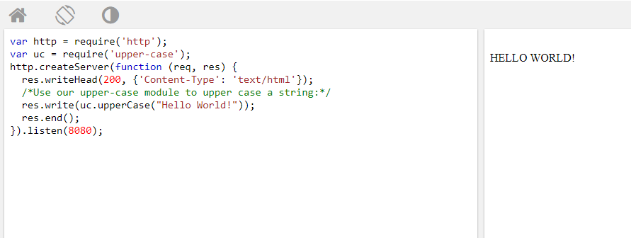

Using nodejs create a web page to read two file names from user and append contents of first file into second file.

